Rodrigo Brasil 10/2023

### **Part 1: Join Endpoint to Domain**

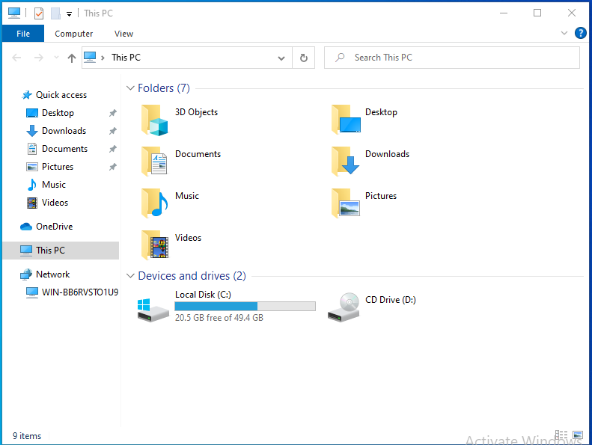

To joint the windows 10 vm into the domain i had to go to “This PC”

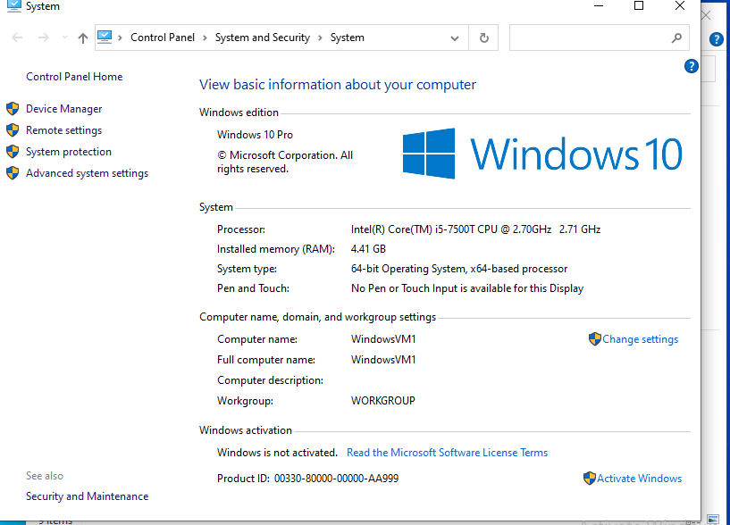

right clicking and clicking on properties, it will open this system window

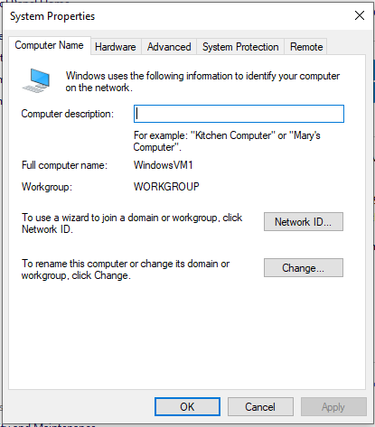

Clicking on the blue text “Change settings” and it will open up the

system properties

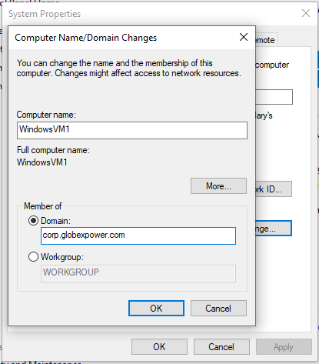

click “Change...” and it will open the computer name/domain changes

in here change from workgroup to Domain and enter the domain

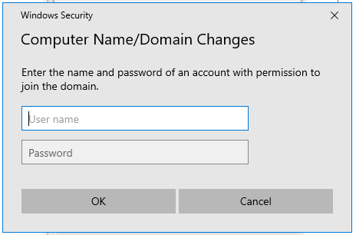

it will ask for username and password, enter the login credentials of the win server vm

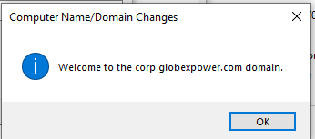

if the credentials entered are correct it will show a pop up welcoming us to the domain and it will ask us to reboot the machine

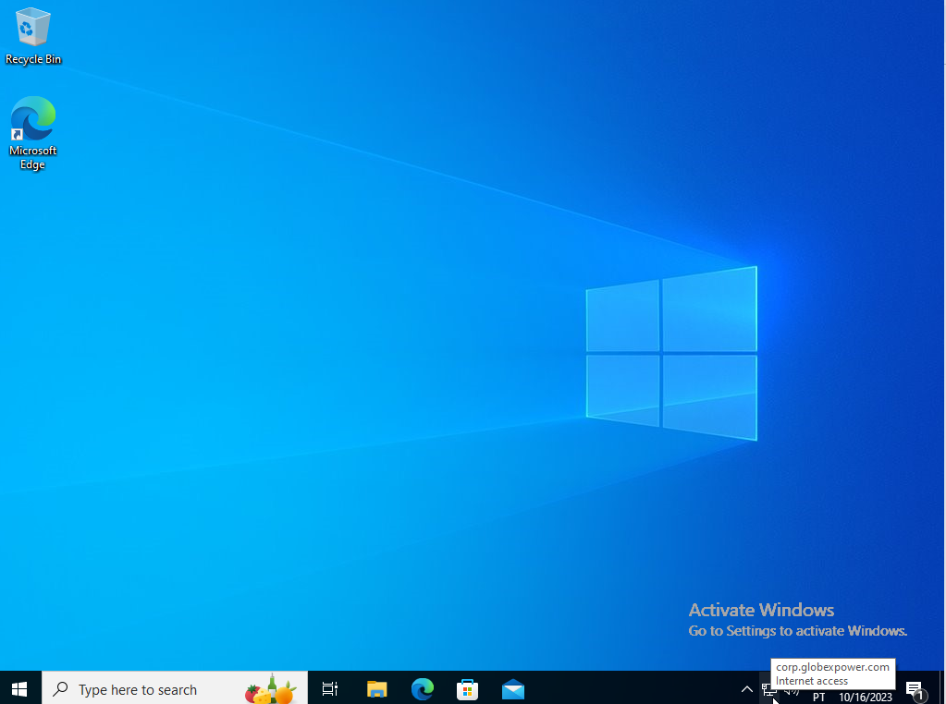

it will ask for login credentials, input the same as usual to login into the machine

after entering we will be on the domain

### **Part 2: AD Profile Creation & Login**

**1. Install RSAT on the Windows 10 Endpoint:**

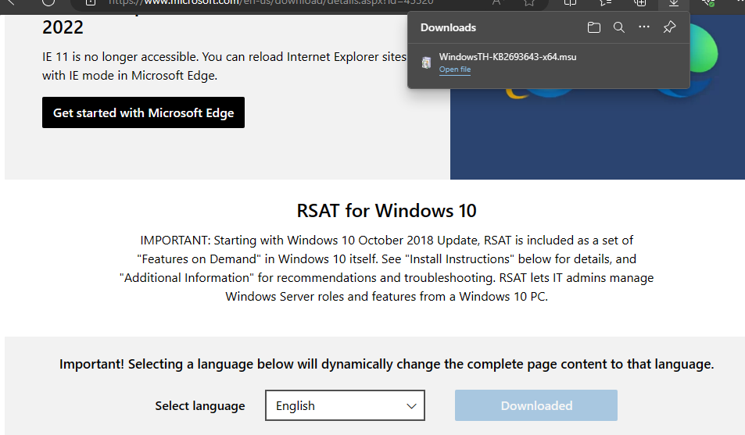

go to a search engine, search RSAT (Remote Server Administration Tools) and download it from the official microsoft page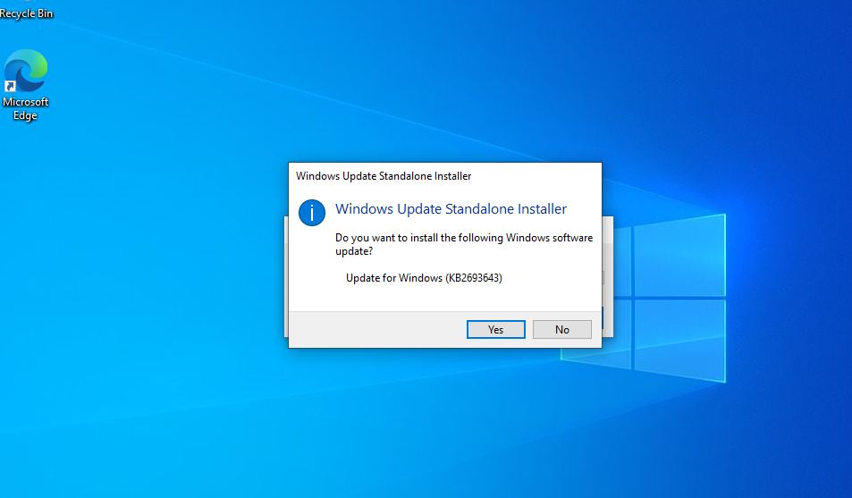

when starting the setup it will ask if we want to update it

click yes

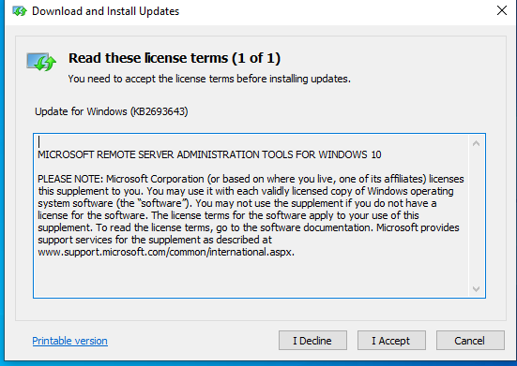

Click “I Accept” to agree with the license terms

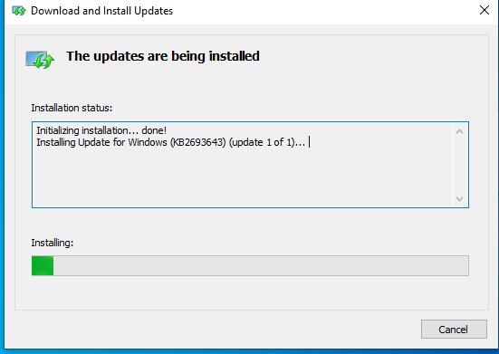

And start the installation

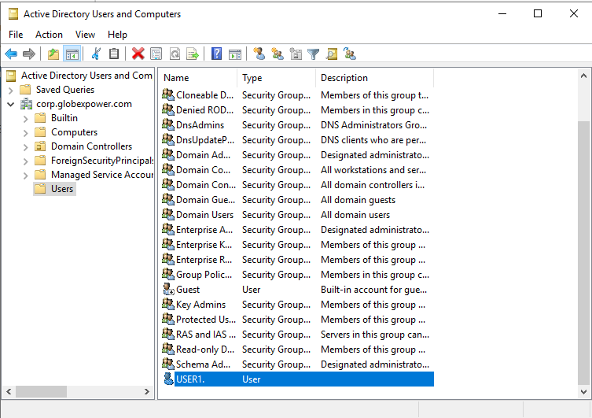

The windows 10 vm computer name was supposed to show up on the “Active directory users and computers” on the win server machine but for some reason it refused to do it.

So i Created a new one and logged in on the win10vm with it.

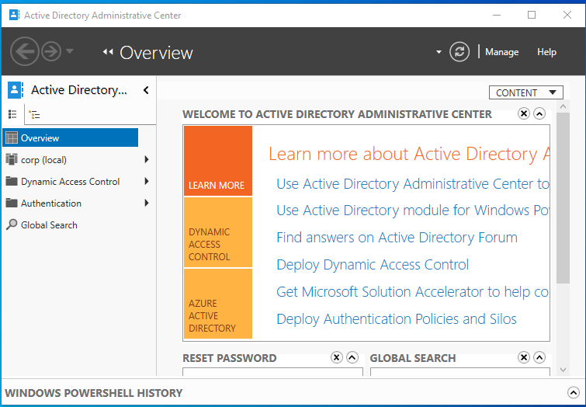

After doing so i am now able to enter “Active directory administrative center”

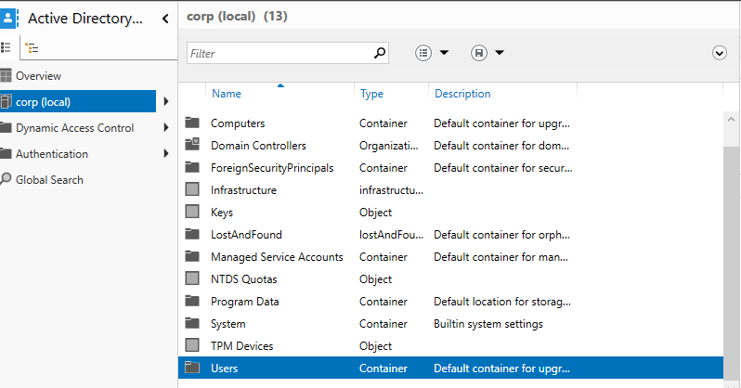

On corp(local) double click on the users folder

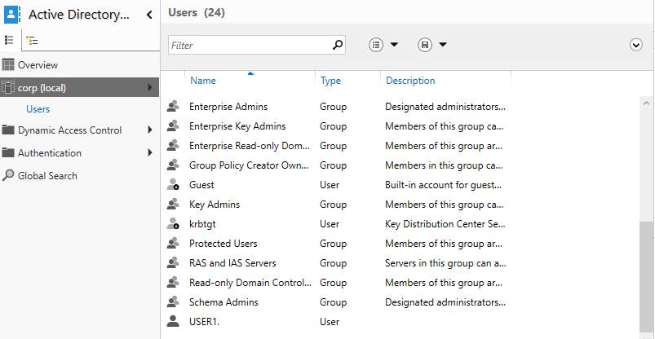

The create new user option was gray because the user did not have admin privileges to make changes.

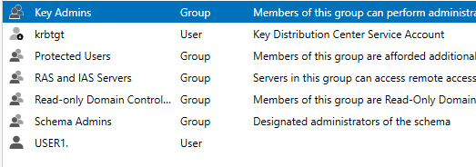

Had to add the USER1. to the group “Domain Admins”

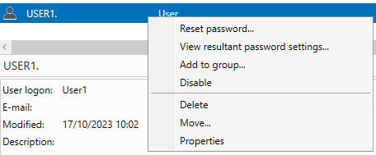

by right clicking the user and clicking add to group…

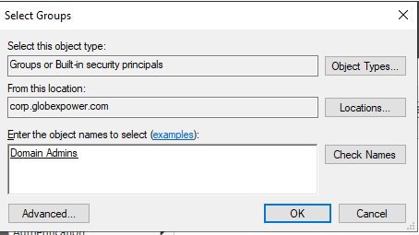

writing the group name in this case (Domain Admins), clicking check names & clicking OK

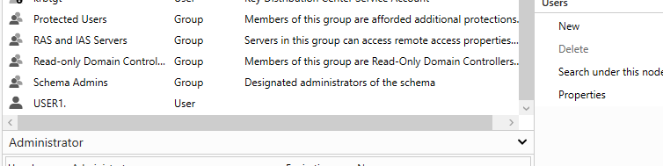

now we have permission to add new users

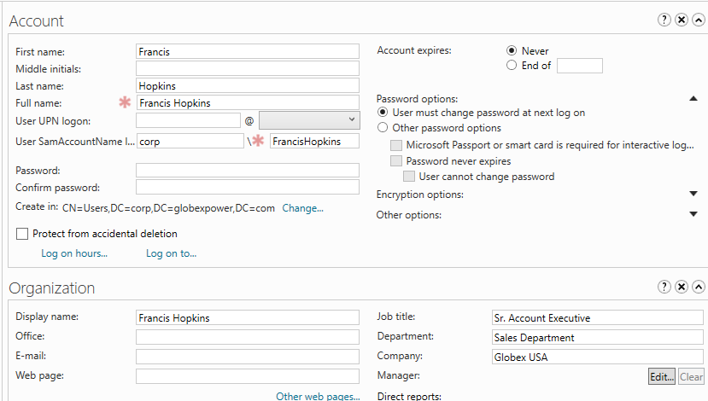

User Francis Hoplins created

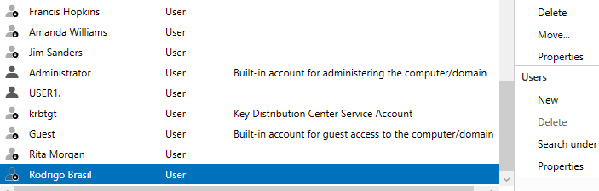

All the new users created (Francis Hopkins, Amanda Williams, Jim Sanders, Rita Morgan & Rodrigo Brasil)

Users accounts are disabled by default because no password was given

### **Part 3: Topology**

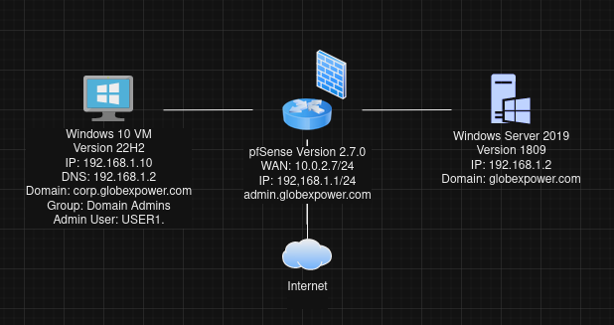Final Topology